# **WIMBLEDON VILLAGE SURGERY**

# DECEMBER 2024

# **NEWSLETTER**

**Practice Manager’s Preamble** Welcome to the December edition of our newsletter. With Christmas fast approaching, I wanted to make sure I wrote again to keep you updated with relevant information – especially regarding Christmas routines, the new appointment system and a lot more!

As ever, we are keen to hear from you and the sort of information you would like to read in these newsletters so please do give us your feedback via our website or the reception desk. Just ask a member of staff to provide you with a feedback/comments/suggestions form! As ever, the newsletters are available from reception but are also available on our website: [Wimbledon Village Surgery - Newsletters](https://www.wimbledonvillagesurgery.co.uk/pages/Newsletters).

**Patient Triage** It has been nearly 3 months since we implemented our new appointment booking system and after some initial teething issues and changes, along with listening to patient and staff feedback, we believe we now have a system that is proving to provide excellent efficiency, plenty of appointment capacity and access and a reduction in phone call queues on a daily basis.

**Benefits seen so far**:

* All appointment requests triaged by a GP
* Appointments offered on a time appropriate basis versus clinical need
* Request/Appointment turn-around is very quick – most patients are offered an appointment within hours of sending in a form; urgent cases are often seen within 1-2 hours
* Patients are able to self-book and therefore choose when they want to be seen and with whom (if specified on the form)
* We are able to offer more GP-appropriate appointments
* We are able to better signpost patients to alternative clinical experts
* GPs receive more information prior to your appointment, ensuring a more efficient consultation
* Telephone calls have reduced by >40%, thereby reducing call waiting times and queuing
* Patient Satisfaction has increased as a result of all of the above with fewer complaints also being received

We appreciate this was a big change in the way we do our business and in the way we ask you to engage with us, so thank you to all that have embraced the change.

**Digital Registrations** To ensure the registration process is as seamless and stress-free as possible and available to all, we have implemented a ‘Digital Registration’ process. Registrations of new patients can now be done wholly online without the need to produce Identification Documentation should the patient not have access to it. Please spread the word to anyone you may know looking to register with a GP practice. The process is simple and efficient for both patient and the practice.

**FLU Season You may have seen the news on the TV regarding the advice to ensure you get your Flu Vaccination this year to protect yourself and to help the burden on the NHS.** Please book your vaccination with us if eligible:

* All patients over 65 years of age
* Any patient aged 18-64 in clinical risk groups
* All pregnant women
* Carers – those in receipt of carers allowance
* Household contacts of immuno-compromised individuals
* Frontline health and social care staff

**Lab Results Reporting** For those of you undergoing laboratory investigations such as Blood Tests please note that you will now be sent a text message informing you of your **NORMA**L lab test result. This is a new automated system (fully tried and tested). All other results remain under the careful review of the GPs, and you will be contacted to discuss these, if necessary, as per usual.

**Self Referrals** There are many minor illnesses and conditions where the patient is able to help themselves or seek initial treatment from another Healthcare provider. We have signed up with Pharmacy First – an excellent scheme where patients are able to refer themselves to a Pharmacist to seek advice and treatment. There is plenty of information on this scheme via our website. Please see this link: [THINK - PHARMACY FIRST - Wimbledon Village Surgery](https://www.wimbledonvillagesurgery.co.uk/pages/THINK---PHARMACY-FIRST)

**Christmas Messages** We will inevitably have a reduction in staff across the Christmas period as we all take some time out to spend with family and to have a break. The services you experience will not diminish, however. Doctors and other healthcare professionals and Administration staff will still be here to help you as and when you need it.

The patient triage system will still be operational and all requests for an appointment will be dealt with on the day they are received. Please note that you are able to raise a request between 8am and 6pm on weekdays.

Please note that we will only be closed on the following days: Christmas Day; Boxing Day; New Years Day (and of course weekends).

You may not always be able to see your preferred GP; so, thank you in advance for remaining flexible and willing to see someone different should you need.

Finally, it has been an extremely busy year for all at WVS – thank you for sticking with us. 2025 promises to be just as busy, but we have confidence in our systems and processes and in the excellent healthcare we provide.

**We wish you all a very MERRY CHRISTMAS!**

**Health Promotion: Cancer Care** This month we will be focussing on Lung Cancer. Lung cancer is one of the most common cancers in the UK, but outcomes are consistently poor. One reason for this is that people are often diagnosed at a late stage, where there are fewer treatment options available. Across the health sector, there is a desire to improve lung cancer outcomes, but this is complex and needs to be tackled using different approaches

In 2022, [the UK National Screening Committee (UK NSC) recommended](https://view-health-screening-recommendations.service.gov.uk/lung-cancer/) introducing a targeted lung cancer screening programme across the UK.

In June 2023, [the Government announced](https://www.gov.uk/government/news/new-lung-cancer-screening-roll-out-to-detect-cancer-sooner) the national roll out of a targeted lung cancer screening programme in England. People aged 55 to 74 with a GP record including a history of smoking will be assessed and invited for screening and smoking cessation services.

How screening works: Step: 1

**Patient invitation**

People aged 55 to 74 with a GP record including a history of smoking will be invited for an initial assessment.

GPs can support lung screening by ensuring that smoking history is accurately recorded within their patient records to ensure that all eligible patients are invited to a TLHC.



Step: 2

**Initial assessment**

The initial assessment will involve the participant answering questions to determine if they are at a high risk of lung cancer.

If they are, they will then be offered a low dose CT scan of the lungs. Smoking cessation support will also be offered for those who need it.

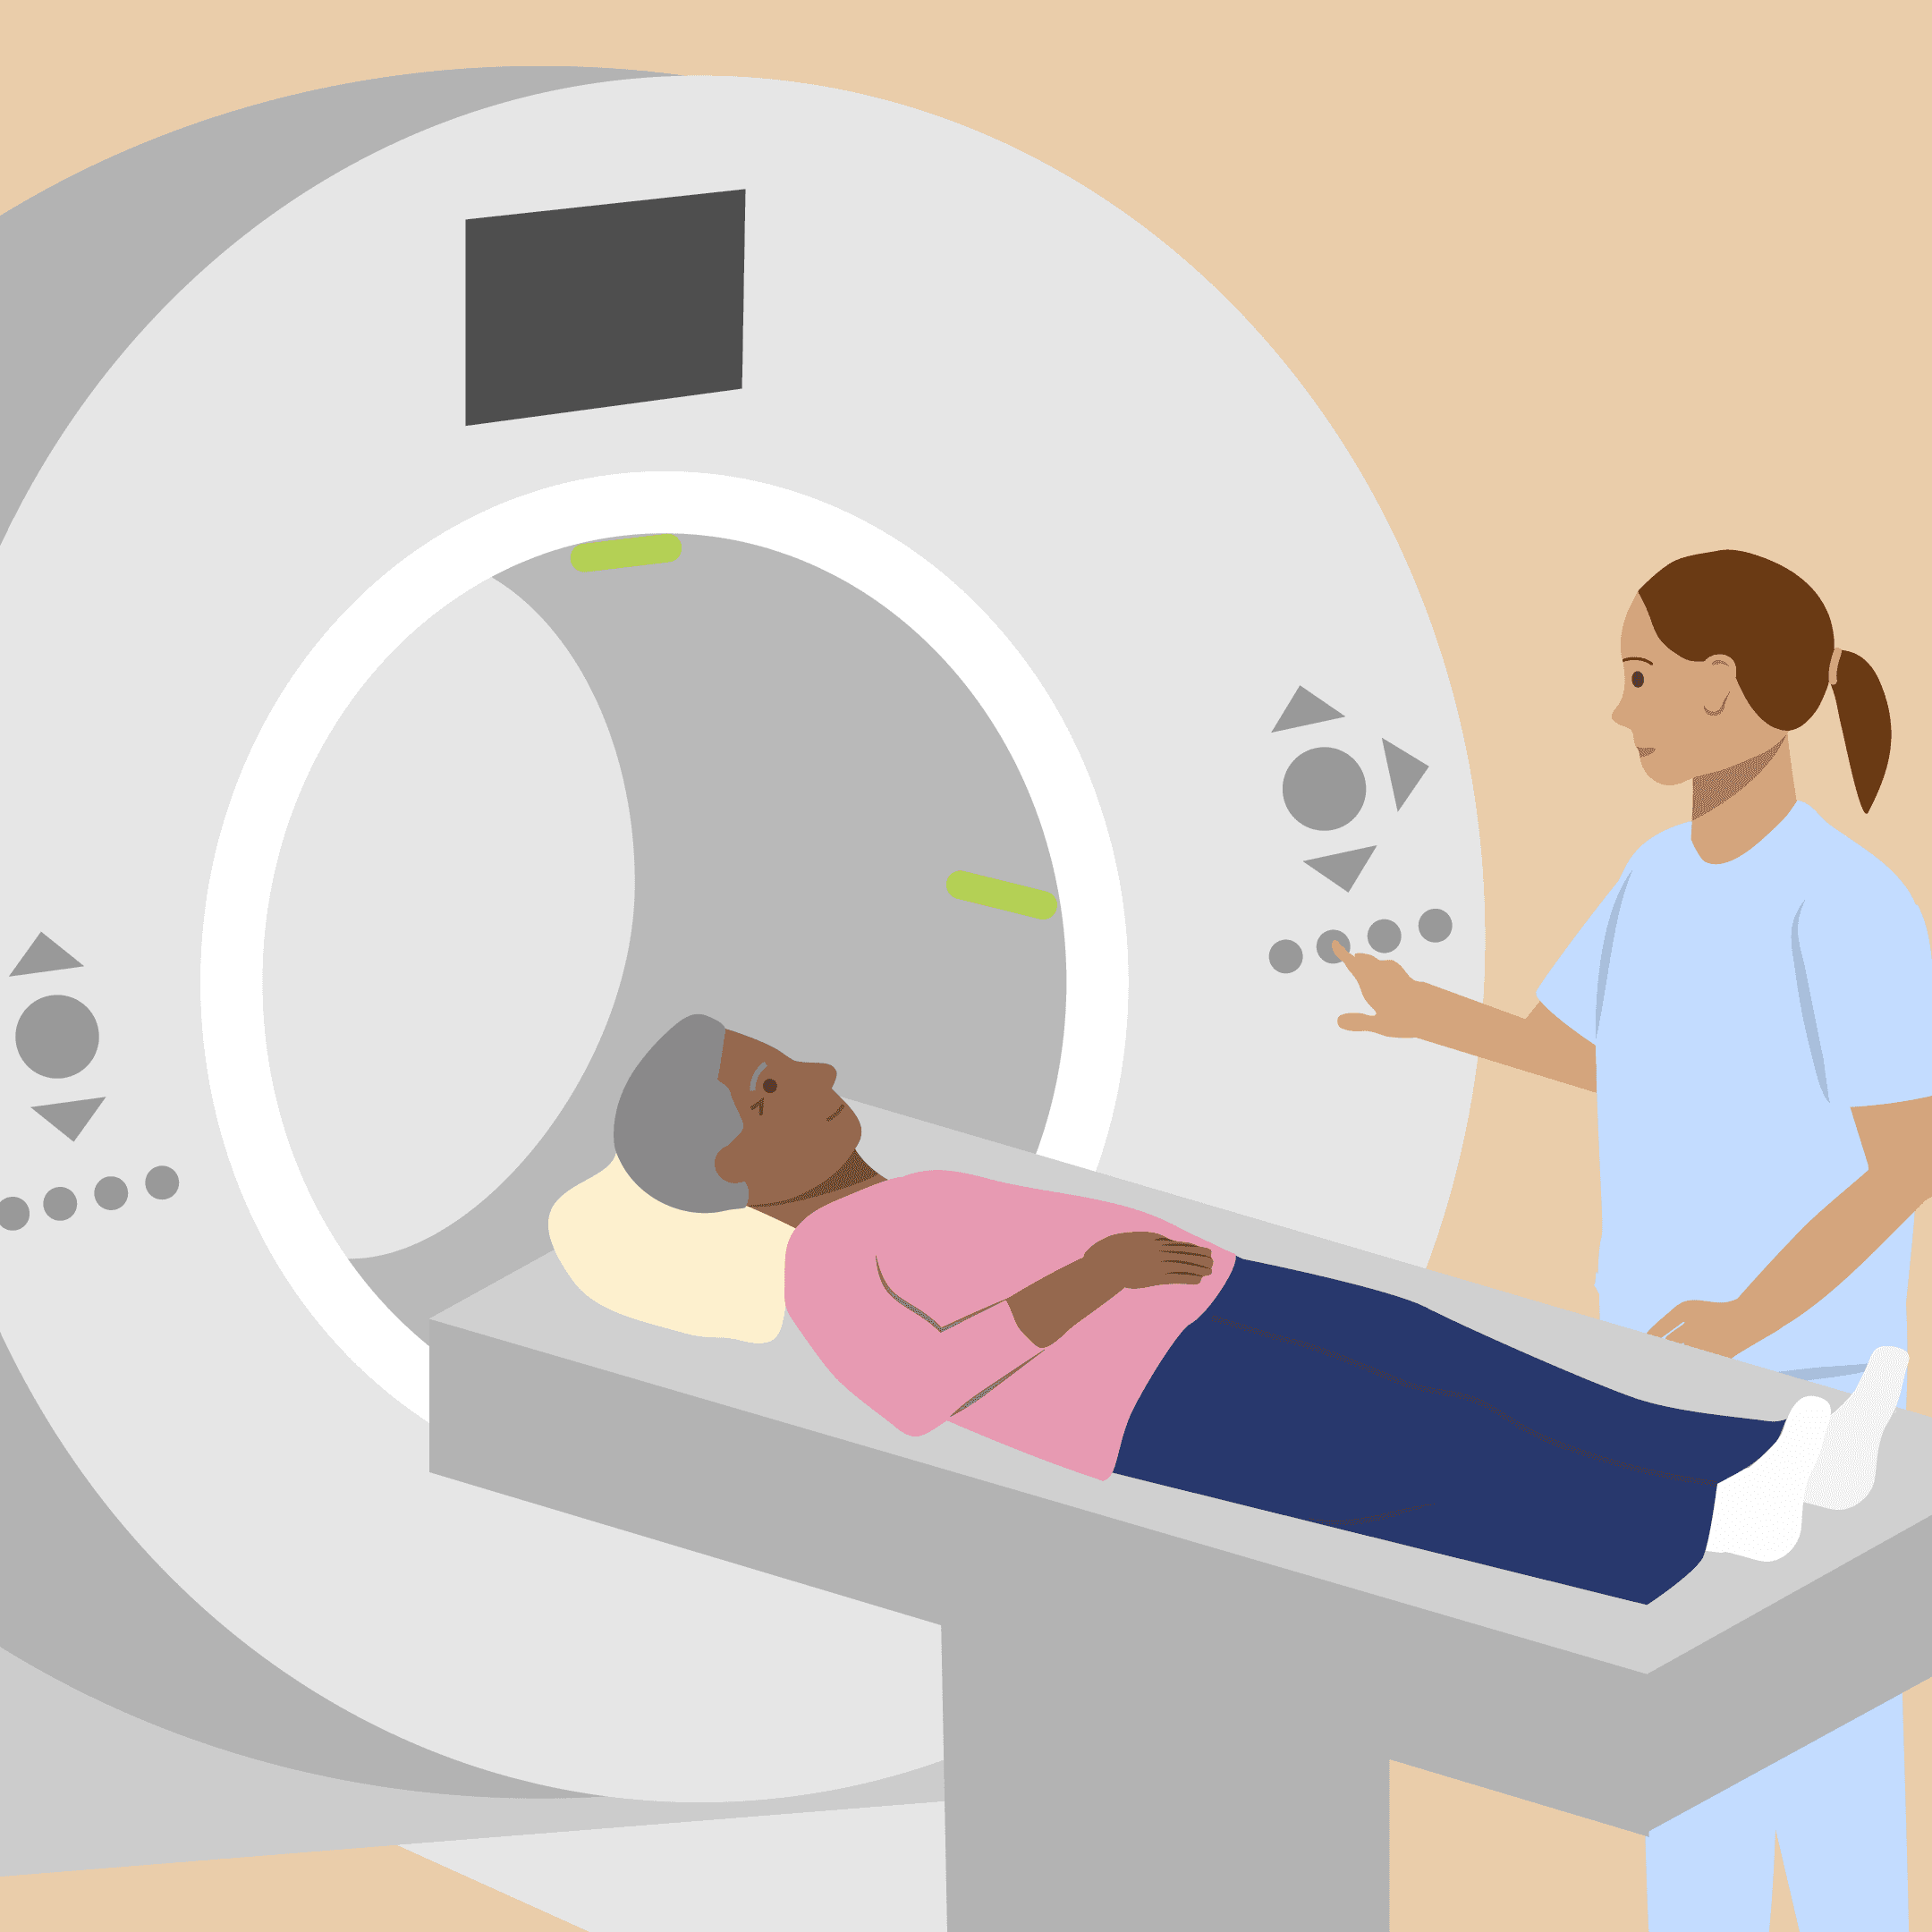

Step: 3

**Low dose CT scan**

A low dose CT scan helps to check for changes in the lungs that may be lung cancer.

The scan creates detailed pictures of the lungs from different angles to form a 3D image.



Step: 4

**Outcome**

If somebody has suspected lung cancer, they will be referred for diagnostic tests as soon as possible.

If other abnormalities are found, they may be invited to screening more regularly.